PART-A
1. Check if a number belongs to the Fibonacci Sequence.
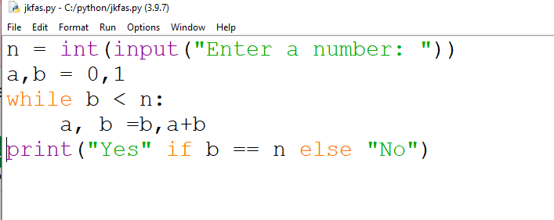
Output :
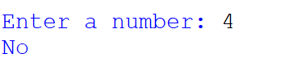
2.Solve Quadratic Equations
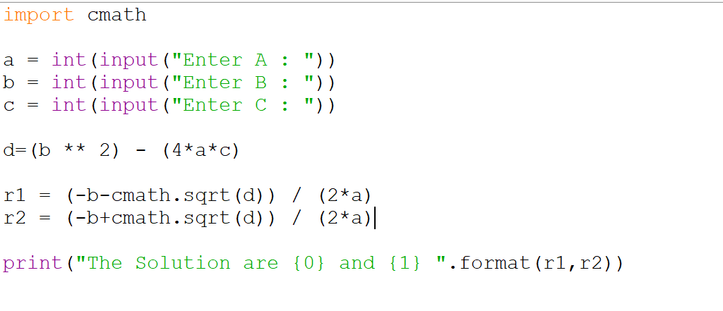
Output : 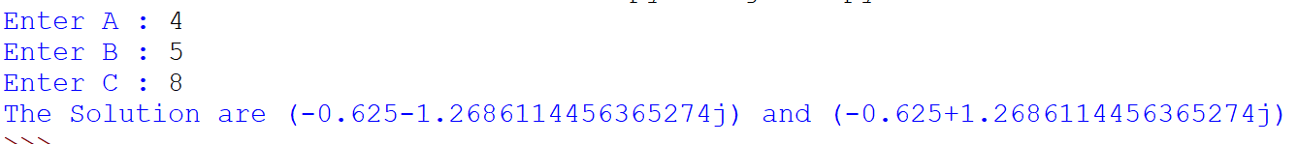
3. Find the sum of n natural numbers
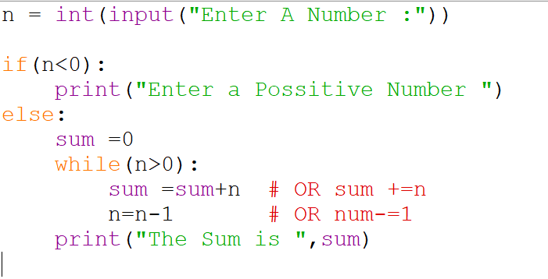
Output :
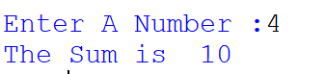
4. Display Multiplication Tables
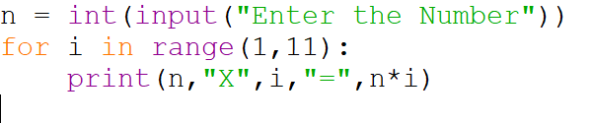
Output :
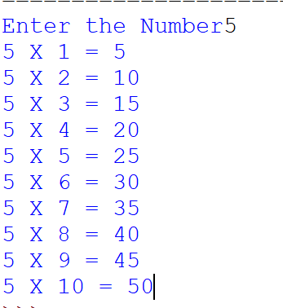
5. Check if a given number is a Prime Number or not

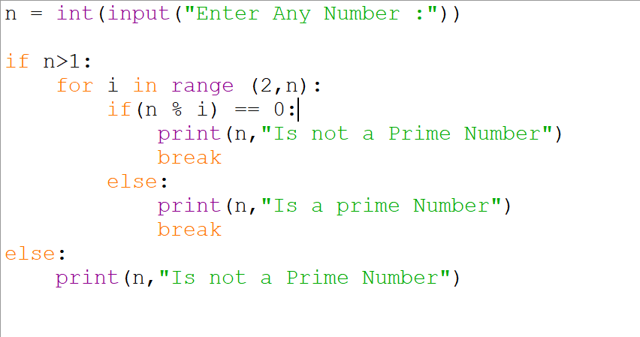
Output :

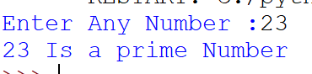

6. Implement a sequential search

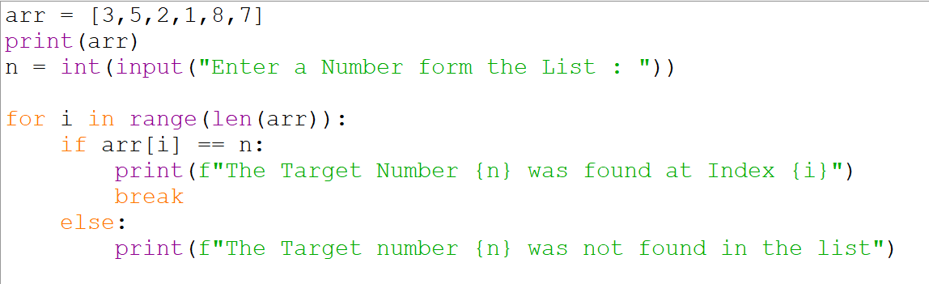

Output :
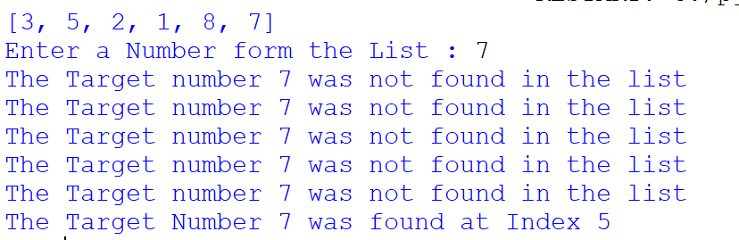

7. Explore string functions

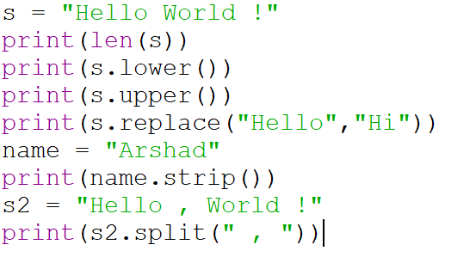
Output :
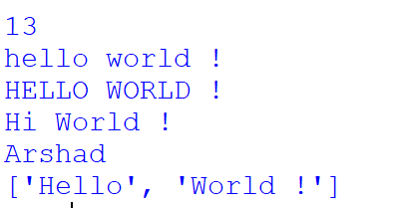

8.Implement of Stack
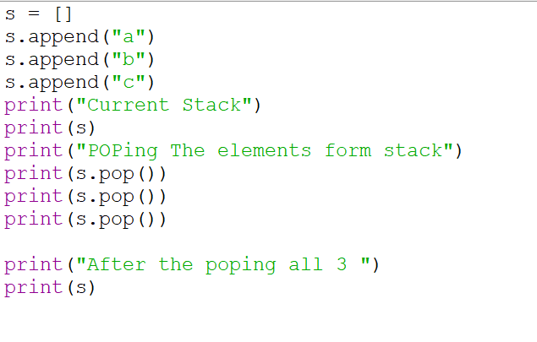
Output:
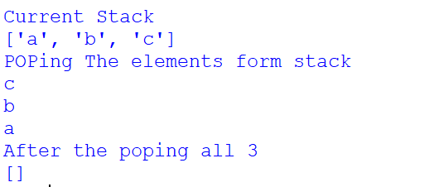

PART B
- Read and write into a file

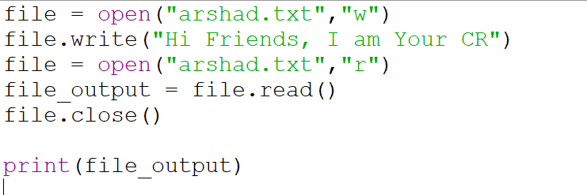

Output:

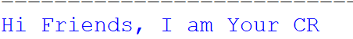

2. Demonstrate usage of basic regular expression
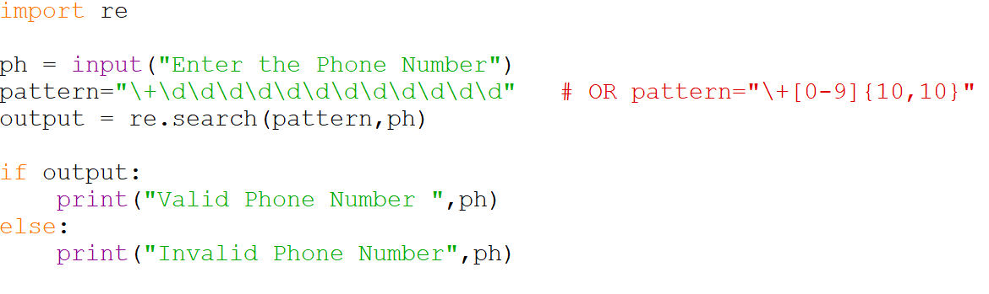
Output :

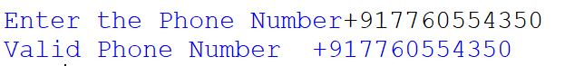

3.Demonstrate use of advanced regular expressions for data validation

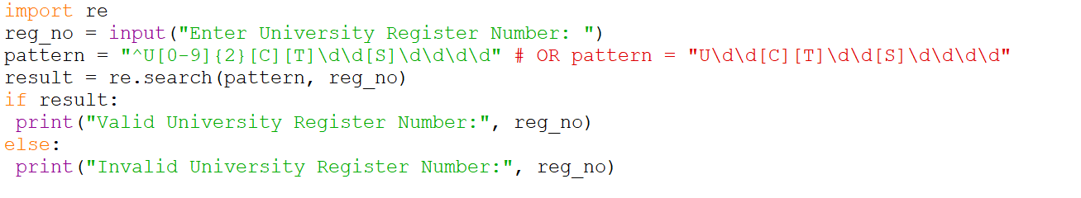

Output :
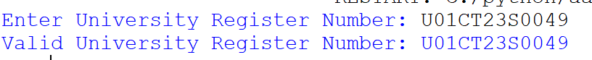

4. Demonstrate use of List

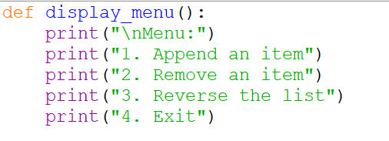

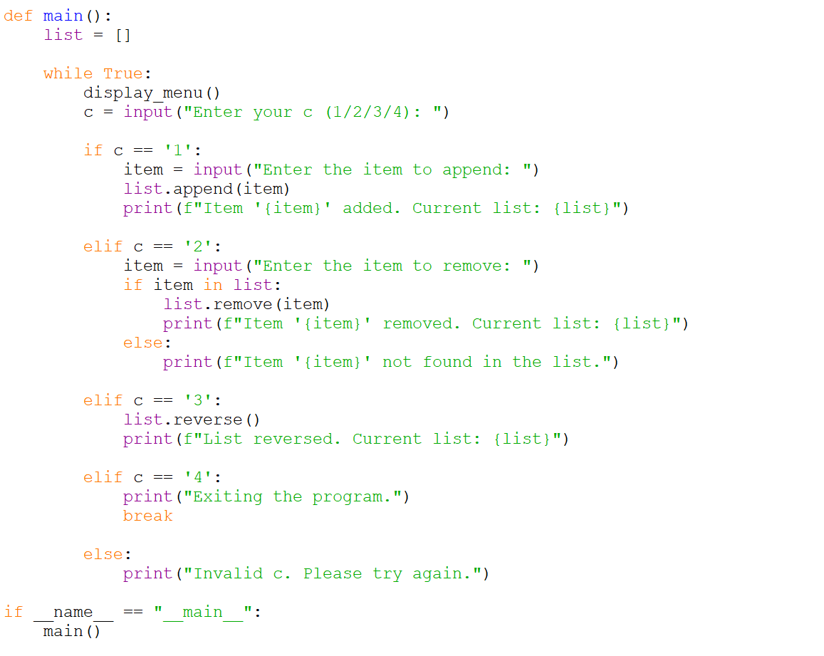

Output :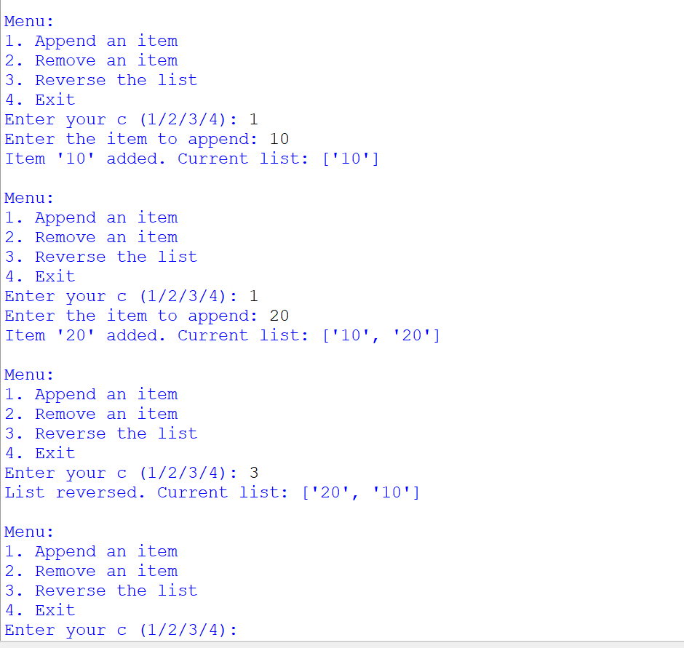

5. Demonstrate use of Dictionaries 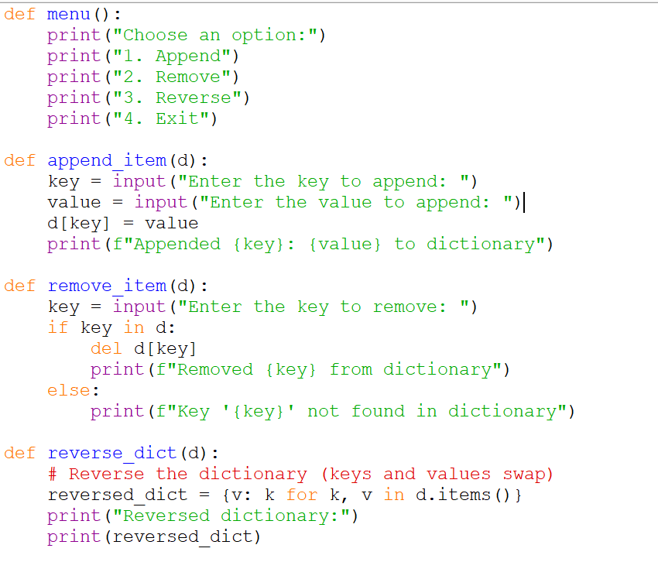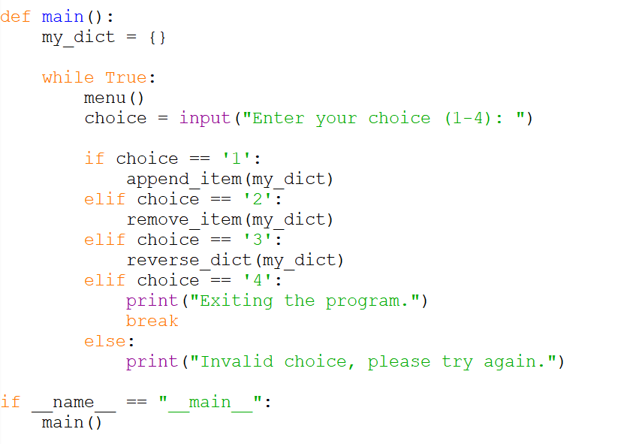

Output :

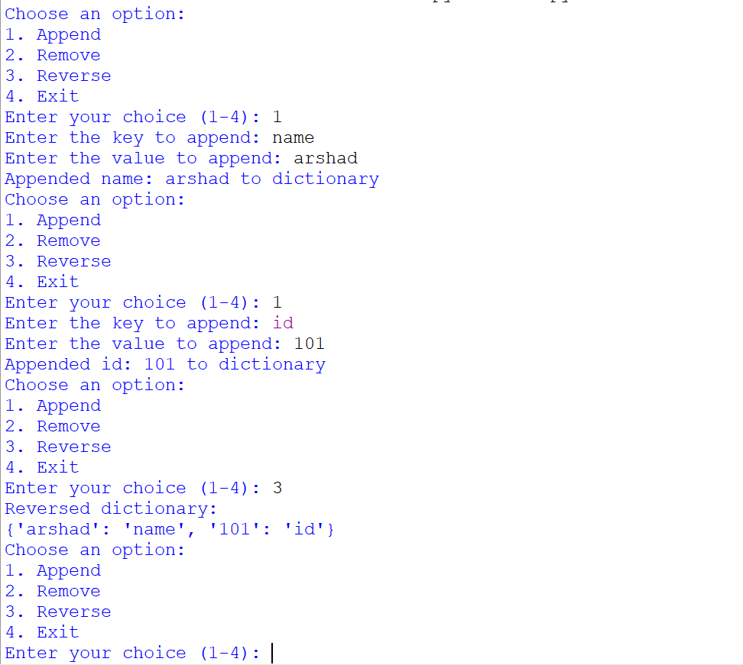

6. Demonstrate Exceptions in Python

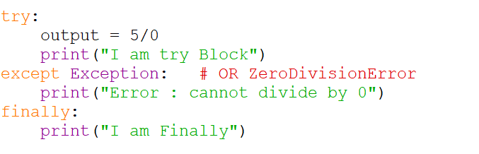

Output :
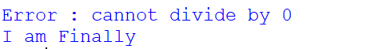

ALL BEST Friends

